Appointment Overview  
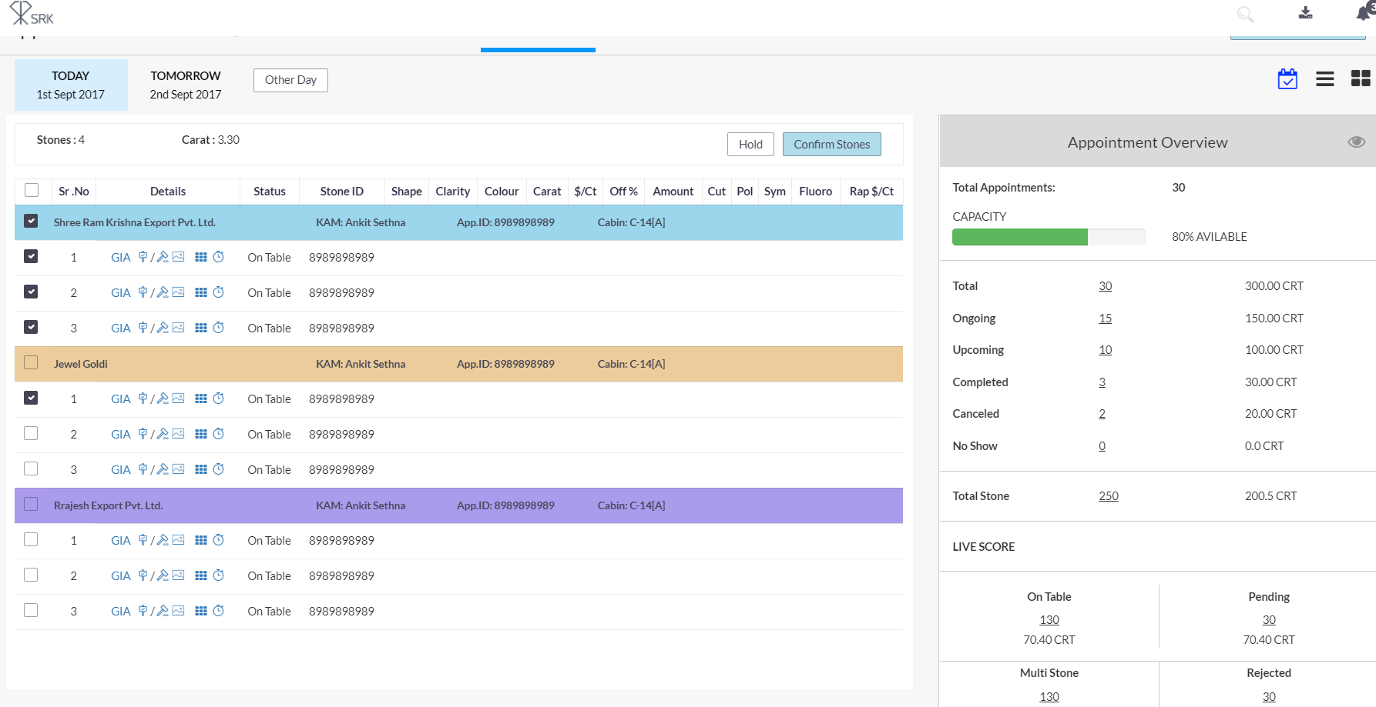

🡪Right Panel of overview specification.

**Total Appointment:** Today’s Total Appointment.

**Capacity**: Average Available slot in Cabin.

**Count** count as total appointment

**Carat** Total Appointment Carat

**OnGoing**: Count Means no of Appointment

**Count** Start Time is not null and completed time is null and close date time is null and isActive(True)

**Carat** Sum of Appointment Carat.

**UpComing:**

**Count** Start Time is not null and completed time is null and close date time is null and isActive (True)

**Carat** Sum of Appointment Carat.

**Completed:**

**Count** Start Time is not null and completed time is not null and isActive True

**Carat** Sum of Appointment Carat.

**No Show:**

**Count** Running Time > Appointment close time and isActive(True)

**Carat** Sum of Appointment Carat.